1. Capture and analyze ARP packets using Wireshark. Inspect the ARP request and reply frames when your device attempts to find the router’s MAC address.
Discuss the importance of ARP in packet forwarding.
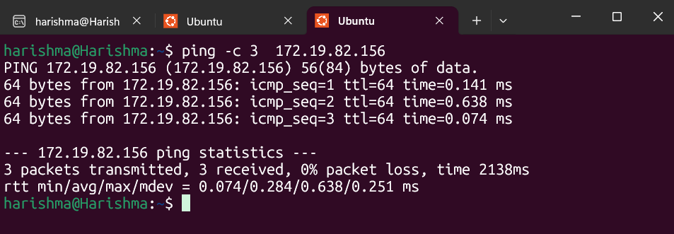
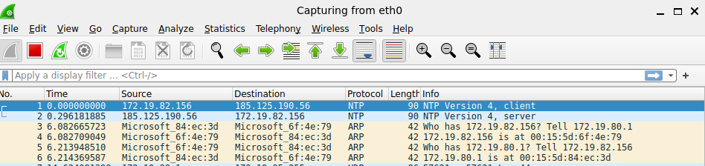
ARP (Address Resolution Protocol) is used to map an IP address to a MAC address within a local network.
When a device wants to communicate with the router, it sends an ARP request asking “Who has the IP address of the router?”. The router responds with its MAC address in an ARP reply.
This process is essential because communication on a LAN uses MAC addresses, not IP addresses.
Without ARP, devices would not be able to forward packets to the correct destination in a local network.
2. Manually configure static routes on a router to direct packets to different subnets.
Use the ip route command and verify connectivity using ping and traceroute.
Static routing is used to manually define paths for packet forwarding between networks.
The ip route command allows administrators to specify the destination network and the next-hop IP address.
Connectivity is verified using:
- ping: checks reachability
- traceroute: shows the path taken
Static routing is simple but not scalable for large networks.
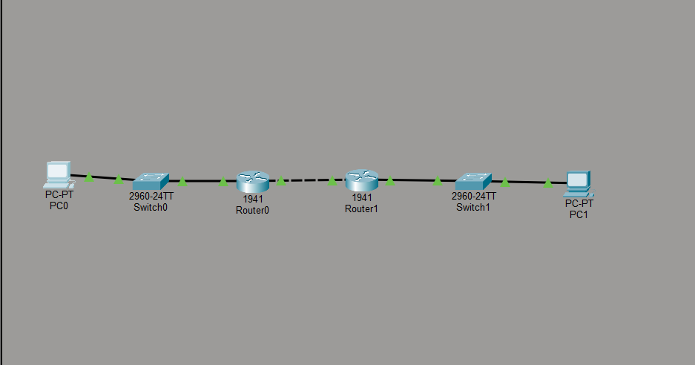
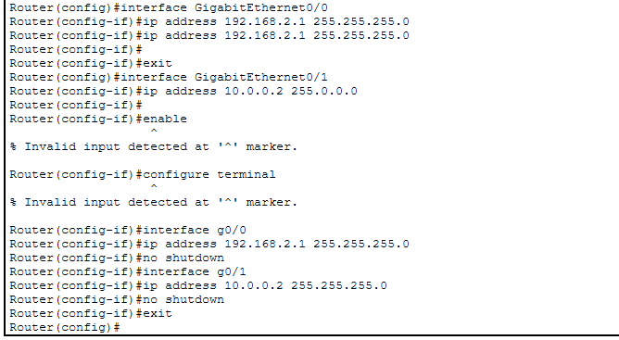
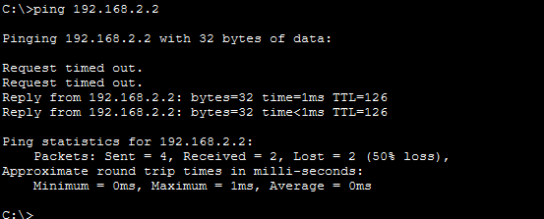
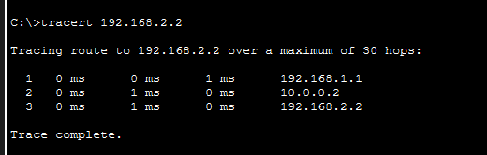
3. Given a network address of 10.0.0.0/24, divide it into 4 equal subnets.
Calculate the new subnet mask.
Determine the valid host range for each subnet.
Assign IP addresses to devices in Packet Tracer and verify connectivity.

Solution
Given:
10.0.0.0/24
Need:
4 subnets

Step 1: Borrow bits
- 4 subnets = 2² → borrow 2 bits
New subnet mask:
/26 → 255.255.255.192

Step 2: Subnets
Subnet | Network | Host Range | Broadcast
1 | 10.0.0.0 | 10.0.0.1 – 10.0.0.62 | 10.0.0.63
2 | 10.0.0.64 | 10.0.0.65 – 10.0.0.126 | 10.0.0.127
3 | 10.0.0.128 | 10.0.0.129 – 10.0.0.190 | 10.0.0.191
4 | 10.0.0.192 | 10.0.0.193 – 10.0.0.254 | 10.0.0.255

To divide 10.0.0.0/24 into 4 equal subnets, 2 bits are borrowed from the host portion, resulting in a new subnet mask of /26 (255.255.255.192).
Each subnet contains 64 IP addresses (62 usable hosts).
The valid host ranges are:
- 10.0.0.1 – 10.0.0.62
- 10.0.0.65 – 10.0.0.126
- 10.0.0.129 – 10.0.0.190
- 10.0.0.193 – 10.0.0.254

4. You are given three IP addresses: 192.168.10.5, 172.20.15.1, and 8.8.8.8.
Identify the class of each IP address.
Determine if it is private or public.
Explain how NAT would handle a private IP when accessing the internet.
Class | IP Range | Default Subnet Mask
Class A | 1.0.0.0 – 126.255.255.255 | 255.0.0.0
Class B | 128.0.0.0 – 191.255.255.255 | 255.255.0.0
Class C | 192.0.0.0 – 223.255.255.255 | 255.255.255.0

IP Address | Class | Type
192.168.10.5 | Class C | Private
172.20.15.1 | Class B | Private
8.8.8.8 | Class A | Public
IP addresses are classified into classes based on their first octet.
- 192.168.10.5 → Class C, Private
- 172.20.15.1 → Class B, Private
- 8.8.8.8 → Class A, Public
Private IP addresses cannot be used on the internet directly.
NAT (Network Address Translation) converts private IP addresses into a public IP address when accessing external networks. The router replaces the private source IP with its public IP and keeps track of the session using a translation table.

5. In Cisco Packet Tracer, configure NAT on a router to allow internal devices (192.168.1.x) to access the internet.
Test connectivity by pinging an external public IP.
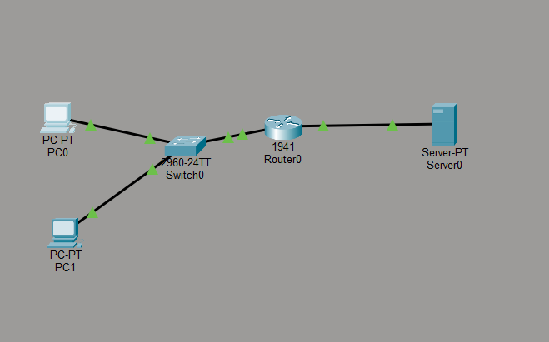

- A network topology was created using Cisco Packet Tracer consisting of two PCs, a switch, a router, and a server representing the external network.
- The devices were connected using copper straight-through cables. The PCs were connected to the switch, the switch was connected to the router, and the router was connected to the server.
- The PCs were configured with private IP addresses:
  - PC0: 192.168.1.2
  - PC1: 192.168.1.3
Subnet Mask: 255.255.255.0
Default Gateway: 192.168.1.1
- The server was configured with a public IP address:
  - IP Address: 200.0.0.2
  - Subnet Mask: 255.255.255.0
  - Default Gateway: 200.0.0.1
- The router was configured using CLI:
  - The inside interface (G0/0) was assigned IP address 192.168.1.1
  - The outside interface (G0/1) was assigned IP address 200.0.0.1
  - Both interfaces were enabled using the no shutdown command
- NAT was configured on the router by creating an access control list to permit the private network (192.168.1.0/24). NAT overload was enabled to translate private IP addresses to the public IP address of the router.
- The inside and outside interfaces were defined using ip nat inside and ip nat outside commands.
- Connectivity was tested by sending a ping from the PCs to the server. The ping was successful, confirming that NAT was properly configured.

Inside local Inside global Outside local Outside global
192.168.1.2 200.0.0.1 200.0.0.2 200.0.0.2

Result
Before NAT, the source IP address was the private IP (192.168.1.x). After NAT, it was translated to the public IP address (200.0.0.1). This confirms that NAT is working correctly.

Conclusion
Thus, NAT was successfully configured in Cisco Packet Tracer, allowing internal devices to communicate with an external network using a single public IP address.

